**National University of Computer & Emerging Sciences**

**Karachi Campus**



**TITLE OF PROJECT: MatCLI**

**Project Report**

**Programming Fundamentals**

**Section: F**

**PF PROJECT REPORT:**

The project is a matrix and scientific calculator which contains the matrix calculations, matrix identities and the mathematical calculations which include arithematic, logarithemic, trigonometric and quadratic calculations.

As soon as the calculator is opened, the menu appears on the screen which prompts the user to enter a number for their desired calculation. For example user will enter 1 for arithematic, 2 for logarithmic and so on.

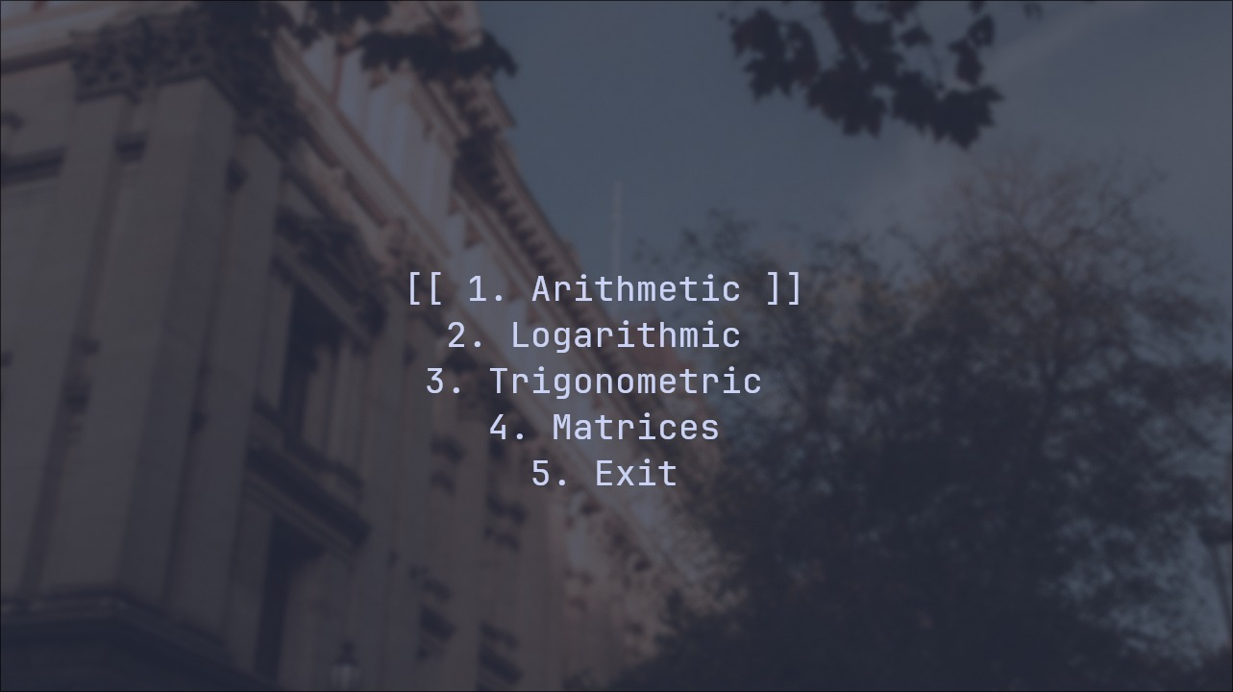

Then the menu for the entered calculation appears which lists down all the operations for that branch. For example if the user wants to do addition (which is an arithematic calculation) user will enter 1 and if subtraction, so user will enter 2 and so on.

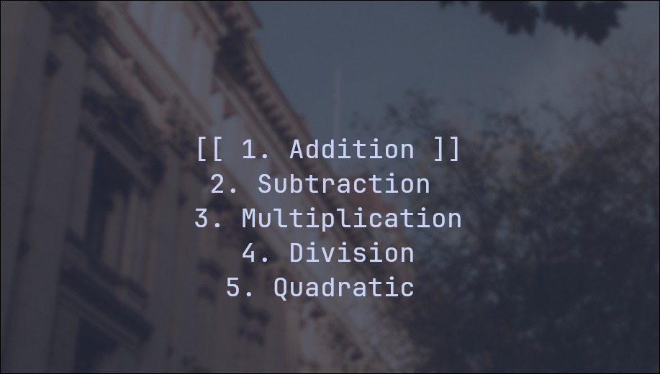

Similarly, for the matrix calculations, the menu is first shown on the screen which has all the identities and matrix calculations listed down.

For matrix calculations:





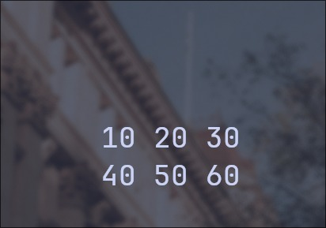

For matrix identities:

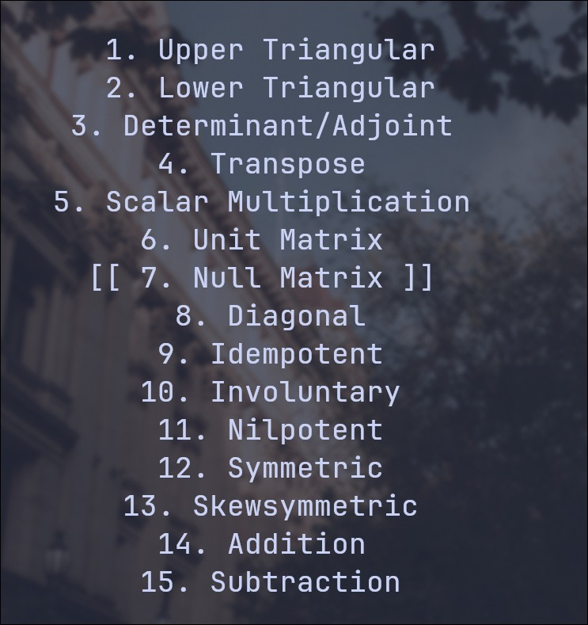

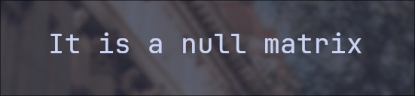

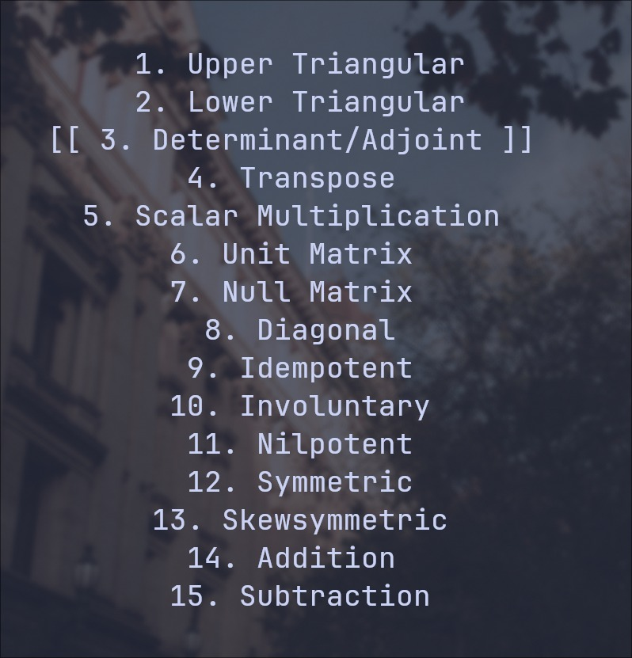

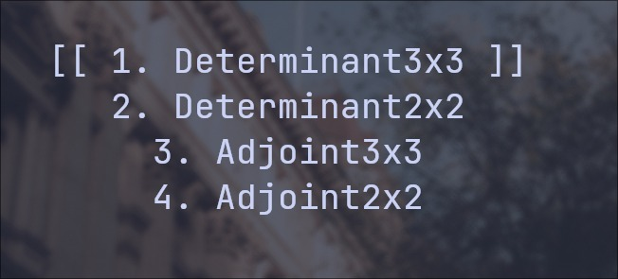

The project also has a feature of printing each text and the resulting calculations in the center of the page, for every console that the program is executed onto. This feature checks the height and width of the console divides and according to the size of the text that is supposed to be printed in the center, prints it in the center of the screen accordingly. This function takes a screen as an input.

**TEAM:**

Hamees Ehsan 23K-0651

Rayyan ur Rehman 23K-0634

Huzaila Asif 23K-0762